FEASIBILITY ANALYSIS

INTRODUCTION:
We are making an online cab booking website like an online travel booking agency.The customer can directly book a cab from here and since this type of websites also exists in market but we are making a little but different.Firstly,we areb starting as a small company and there on we will be improving our website.We have a cab sharing feature in our booking system which makes our website unique from other websites.The customer payment can be done directly to the cab driver and the website we are making is simple for now.We are service providers only for showing the available cabs.
BACKGROUND:
We are implementing the website using different programming languages like Html,Css and bootstrap.These are the languages used for making the user interface.The website currentlly will be making only a sample website but after that we will increase the UI.Since there are many companies like this in the market,the cab sharing feature makes this website unique.The main problem nowadays is that the people who are booking cabs are not exactly aware of fairs and since the drivers also charge more.The solution to this problem is that people who shares the same cab will now have a reasonable fares.Also this is done by the website and hope it can solve the problem.
OUTLINE OF THE SYSTEM:
The main page of the website looks like with a login page and logo of our company.There are two types of customers the registered ones and unregistered ones.Both can see the available cabs online.We keep an employee who checks and update the status of cabs.The customer when find a cab suitable for him must login to book a cab and once he logins he/she is eligible for the facilities of the system.After booking the cab customer can cancel his/her booking within one hour.Now the website made with simple user interface that can handle complex requests from the customer.The main page will be user login page and after logging in website changes and allows the customer to book.After the booking has been done,the details of cab driver and other details will be sent from customer to cab driver and viceversa.Implementing a website and we are like service providers donot make money.So, for the financial part the website allows the ads and from them we can make money.Also we make money from small cab companies that are partners to us.Since they are getting profit by being partners with us and we also ask little share from them.

METHODOLOGY:
We think that our proposed idea will be feasible by examing the results of the survey.We have conducted an survey among different people.In that survey we are having the questions below:
1.Do you have any problem in booking cabs?
2.Have you got frustated in finding mobile number of the cab drivers?
3.How do you thinks about a website which allows you to book cabs?
4.Would you the like to include the cab sharing feature in our website?
After conducting the survey the responses are amazing.We got nearly 80 responces from the different people.we used google docs for the survey it automatically generates the pie charts.so,after examing the data we conclude these sentences:nearly 50% of them are frustated in finding the mobile number of drivers and 25% of them said maybe.Since there are many types of service providers like us in market the 80% of the people says that this website will be of some help.
The main thing is that all wanted to access the website directly through the moodle and that can be done in later versions of our website and the cab sharing feature between the customers.Here are some statistics:
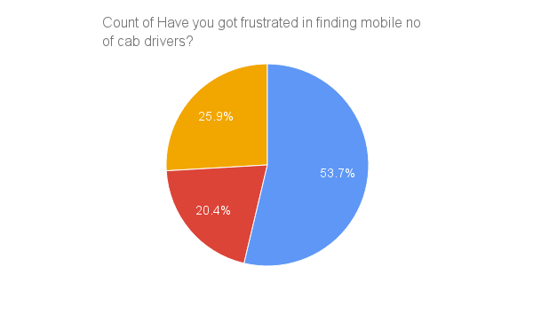
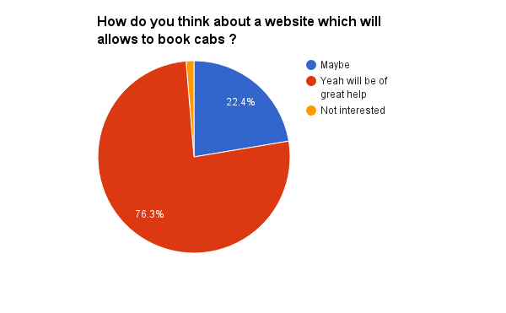
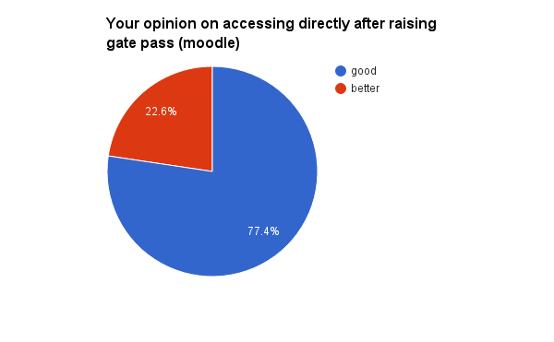
CONCLUSION:
For the cab sharing feature we also have an idea how to implement.There are different ways we can make the website.The concept is that the customer clicks a button on website if he/she wanted to share a cab with other persons.if they wanted to share other persons also can view the same cab and website automatically ignores if the seats were full in the cab.Hence all conclusions of this product can come into final and it is good to implement this.
RECOMENDATION:
Since the survey says that most people are willing to use the website and above stated facilities,the product can be implemented.We the group of people who are making this product thinks this is feasible.

